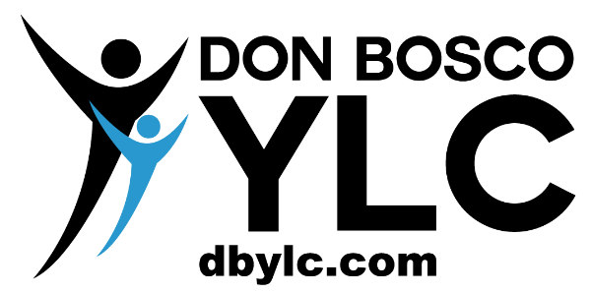
Special events leader 25th anniversary applicant 2022
Thank you for your interest in wanting to share your time and creativity in helping the YLC offer fun and dynamic events for the community to enjoy! Please fill out the application and send back to both theovecera@gmail.com and amy@dbylc.com. We will contact you for a possible discussion on your ideas and plan. We would like to hire the team by early October.

Name:

Age: | Cell: | Email:
How did you hear about the special events contracts?

Special events interested in? Please put only two choices | 1st choice: | 2nd choice:
Please describe your 1st choice ideas and structure (Point form. Write as much as you like).

Please describe your 2nd choice ideas and structure (Point form. Write as much as you like).

Questions or comments you have?

Please take note of the following:
- We are looking for individuals that can plan and lead the event from “A to Z”. The YLC will offer support and guidance and may provide you with 2-3 YLC leaders for support and assistance (your choice).
- You may request to split the contract into two people.
- You can have your friends (or other) help with the planning of the event that are not part of the YLC team.
- We are not looking for a “good” event but a GREAT and memorable event. To achieve this, your scheduling of time, planning and communication skills must be effective, clear and professional.
- Once the event is completed you will be compensated with a personal cheque written to your name. Reference letters can also be given for your portfolio/CV.
Applicant signature: |  | Date:

